**Case study: Train Ticket Reservations**

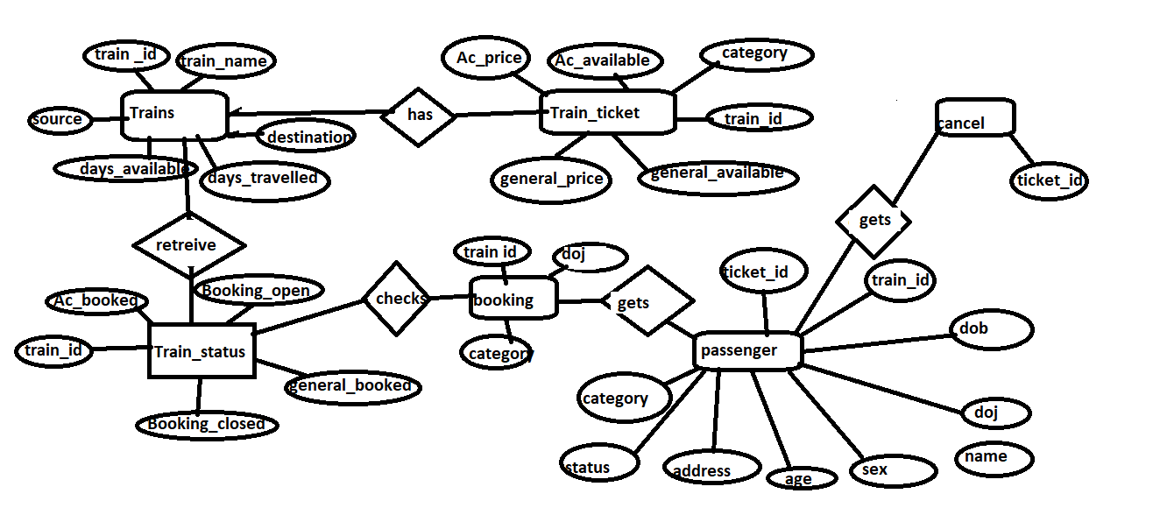

**Entities:Trains,train_Ticket,Passenger,Train_status.**

**Trains:**

**{**

**train_id,train_name,source,destination,days_available,days,travelled**

**}**

**Train_ticket:**

**{**

**Category,Ac_price,Ac,available,general_price,general_available,train_id**

**}**

**Train_status:**

**{**

**Booking_open,Booking_closed,ac,_booked,general_booked,train_id**

**}**

**Passenger:**

**{**

**Train_id,ticket_id,name,age ,sex,address,Dob,Doj(date of journey),status,category**

**}**

**Booking**

**{**

**Train-id,doj,category**

**}**

**Cancel**

**{**

**Ticket_id,name,train_id,doj**

**}**